1️⃣ What is NumPy?
NumPy (Numerical Python) is a Python library used for numerical and mathematical operations, especially with arrays and matrices.

2️⃣ Why is NumPy faster than Python lists?
NumPy is faster because
- it is written in C-NumPy is implemented in C (low-level language
Python lists use Python-level loops (slow
- uses contiguous memory-data stored next to each other in RAM
CPU reads faster
- supports vectorization,-which allows operations on entire arrays without explicit Python loops

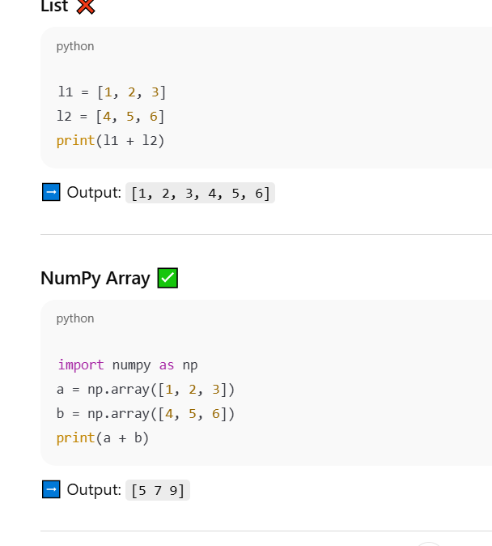

3️⃣ What is an ndarray?
An ndarray (N-dimensional array) is the main data structure in NumPy used to store homogeneous (same-type) data in one or more dimensions
- n → any number (1D, 2D, 3D, …)
- d → dimensional
- array → collection of elements
👉 Means: array of any dimension

4️⃣ Difference between Array and List
Feature | Python List | NumPy Array
Data type | Mixed | Same
Speed | Slow | Fast
Memory | More | Less
Math operations | Loop needed | Vectorized
Dimensions | Mostly 1D | 1D, 2D, 3D
Use case | General programming | numerical computing
5 What is broadcasting?
Broadcasting allows NumPy to perform operations on arrays of different shapes by automatically expending dimensions when possible.

🔹 How Broadcasting Works (Rules)
NumPy compares array shapes from right to left.
Two dimensions are compatible if:
- They are equal
- One of them is 1





